LOGO

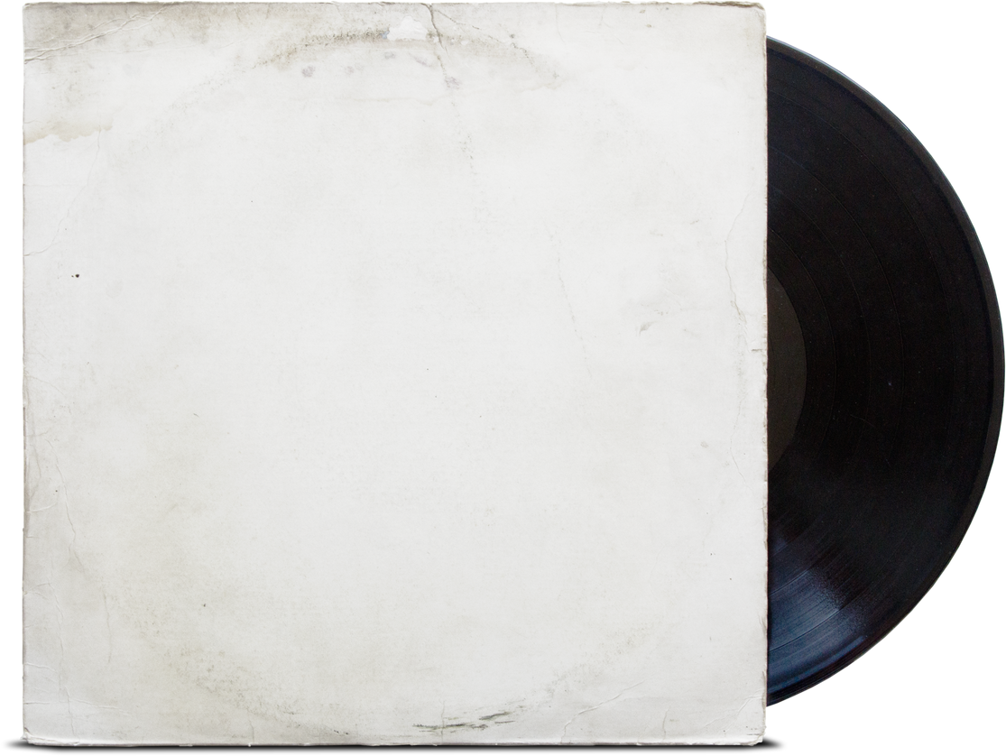
QR Code
My Playlist #4

Instructions: Can you guess who this playlist belongs to?
- Rhapsody in Blue by George Gershwin
- Harder, Better, Faster, Stronger by Daft Punk
- Don’t stop believin’ by Journey

